1. Download Source Code [Here](https://github.com/hammadshahid-170/uploadattachments)
2. First run command **npm install**
3. Then copy **@pnp,jquery,jqueryUI,bootstarp,react-file-viewer,react-file-downloder,react-awesome-modal** folder download from this link [Here](https://github.com/hammadshahid-170/libraryfolders) and paste in node module.
4. **DataFields**

* Name        single line text
* Type       choice (DropDown and enter your values)
* Email         single line text
* Gender      choice (Radio button with value **Male and Female**)

replace your internal name of fields in **UploadDocumentsDataProvider** in src folder mention below pic

in below picture you will change left side internal names mention in red box.

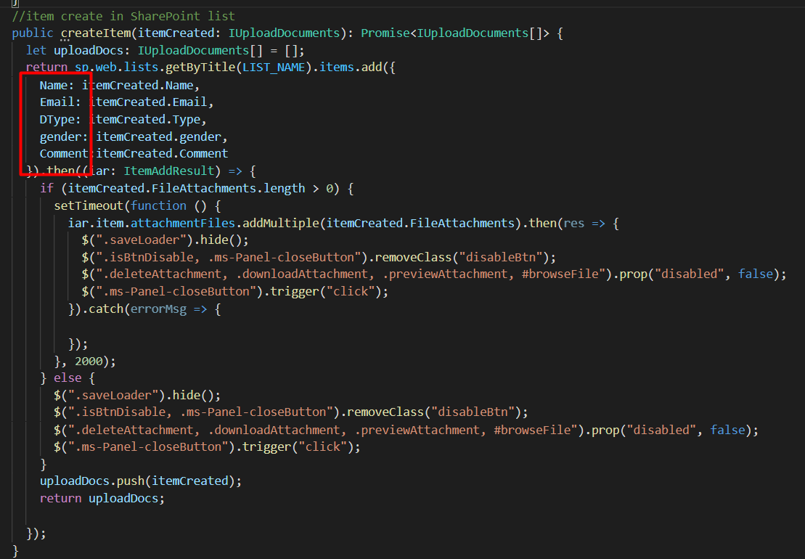

in below picture updateItem function you will change left side internal names mention in red box.

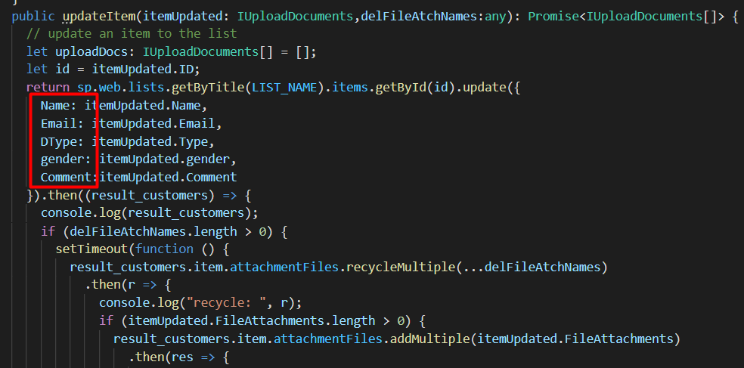

in below picture **getItemById** function you will change right side internal names mention in red box.

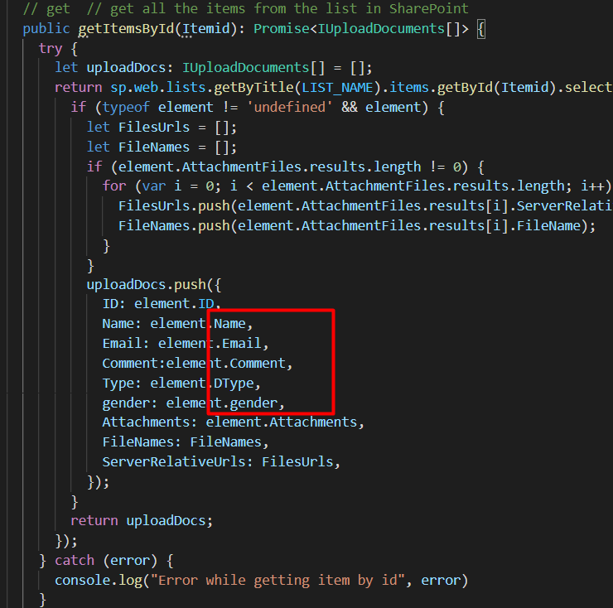

in below picture **getItems** function you will change right side internal names mention in red box.

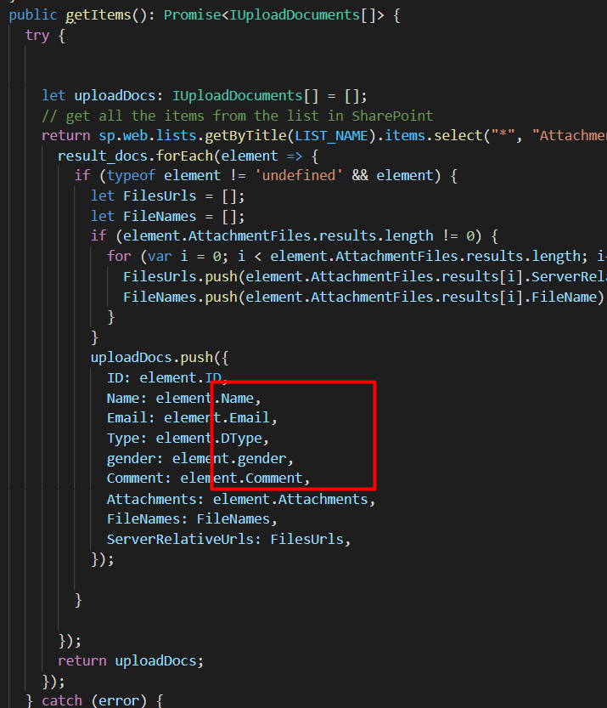

In mention box you will replace your list name and also you will give static link of your site like const **BASEURL** = “your site link”

